**Creation of Account:**

1. Click on Create Account

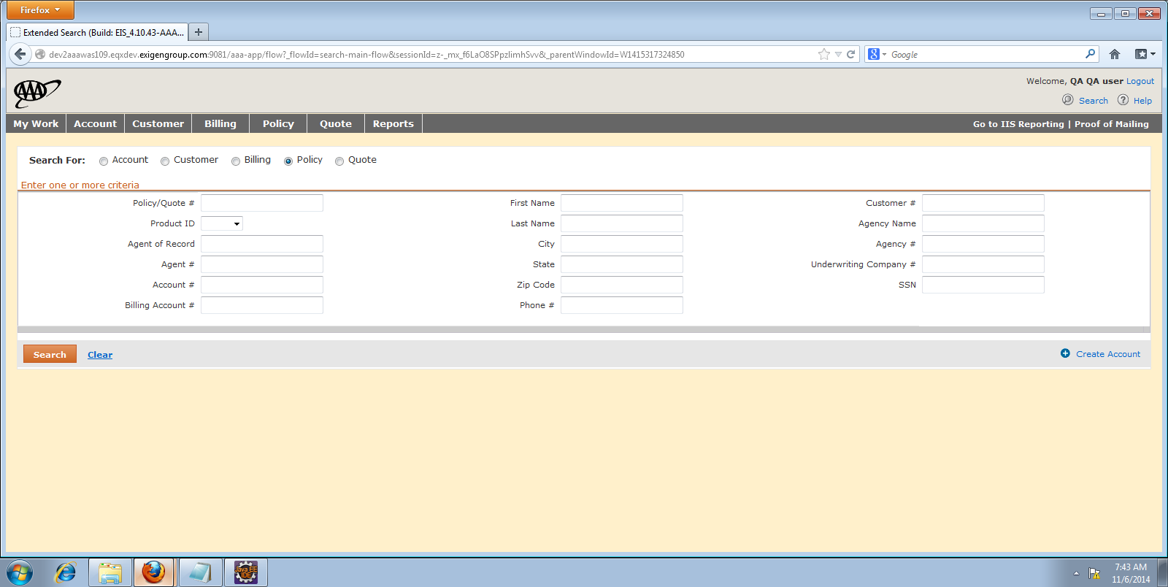

1. Fill the Account Tab and click on Done

**Note: The State in Account creation and Policy creation should be the same.**

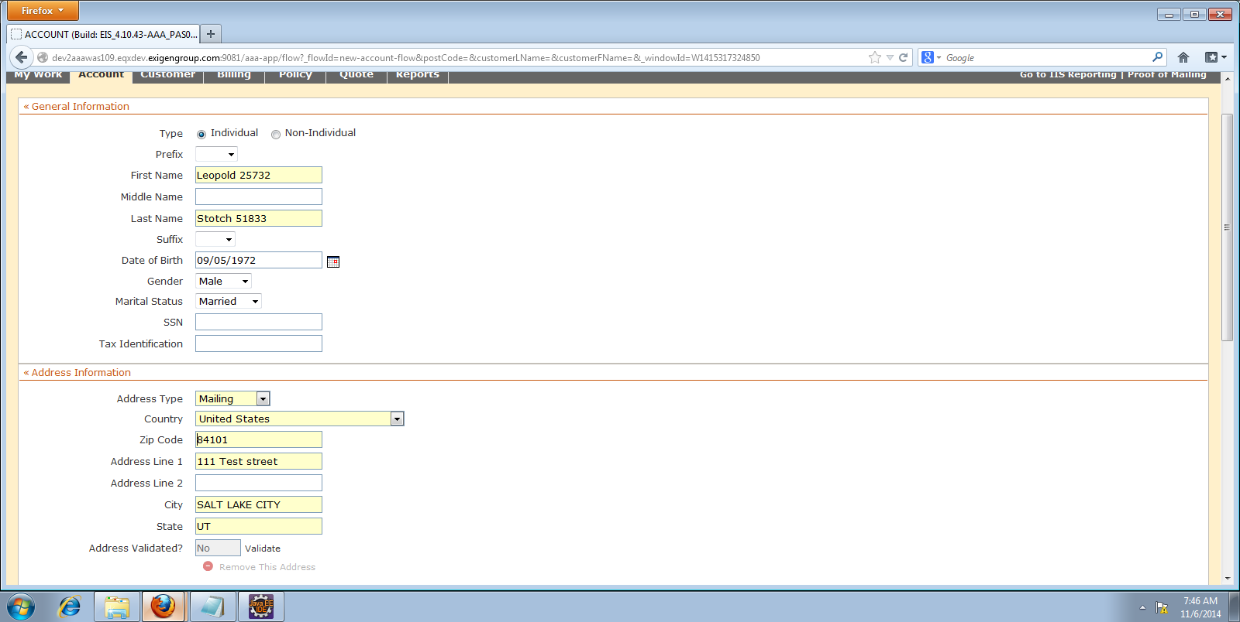

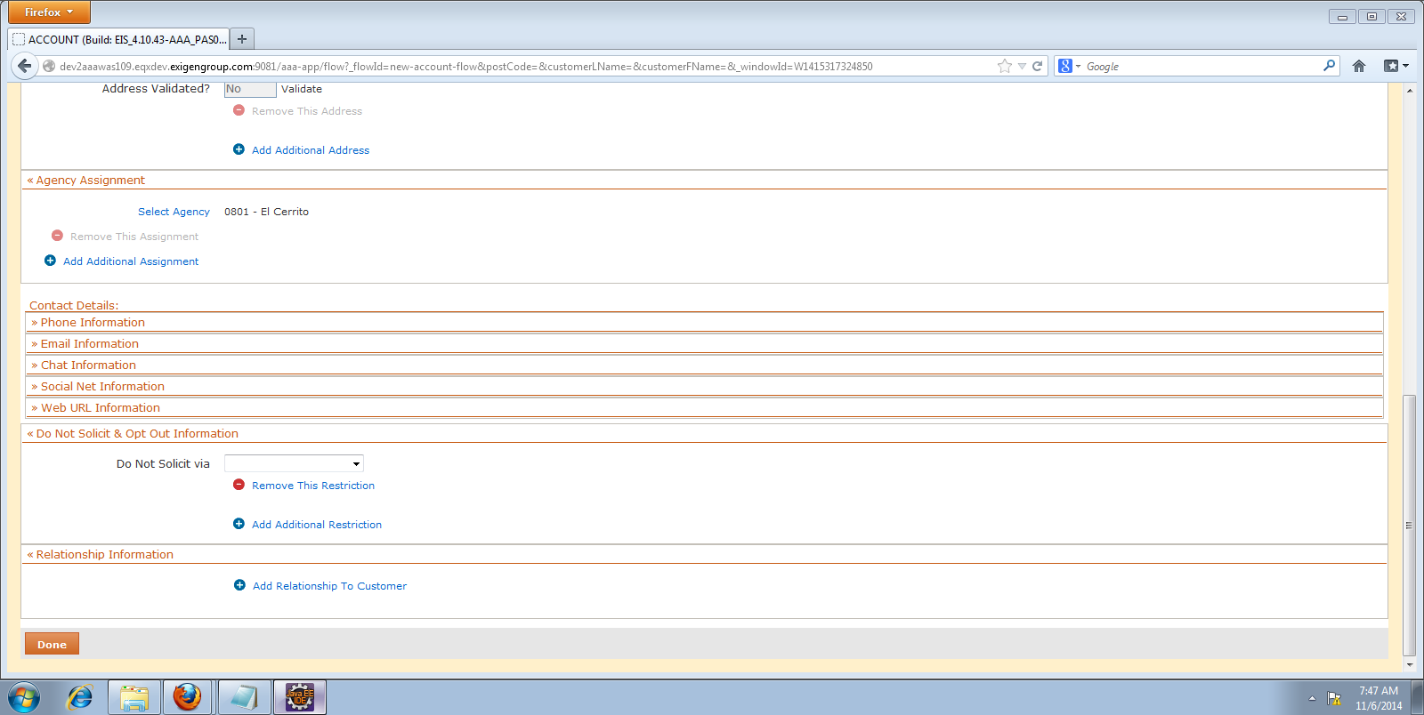

***HO Policy:***

1. Creation of HO Quote:

**Click on Add Quote**

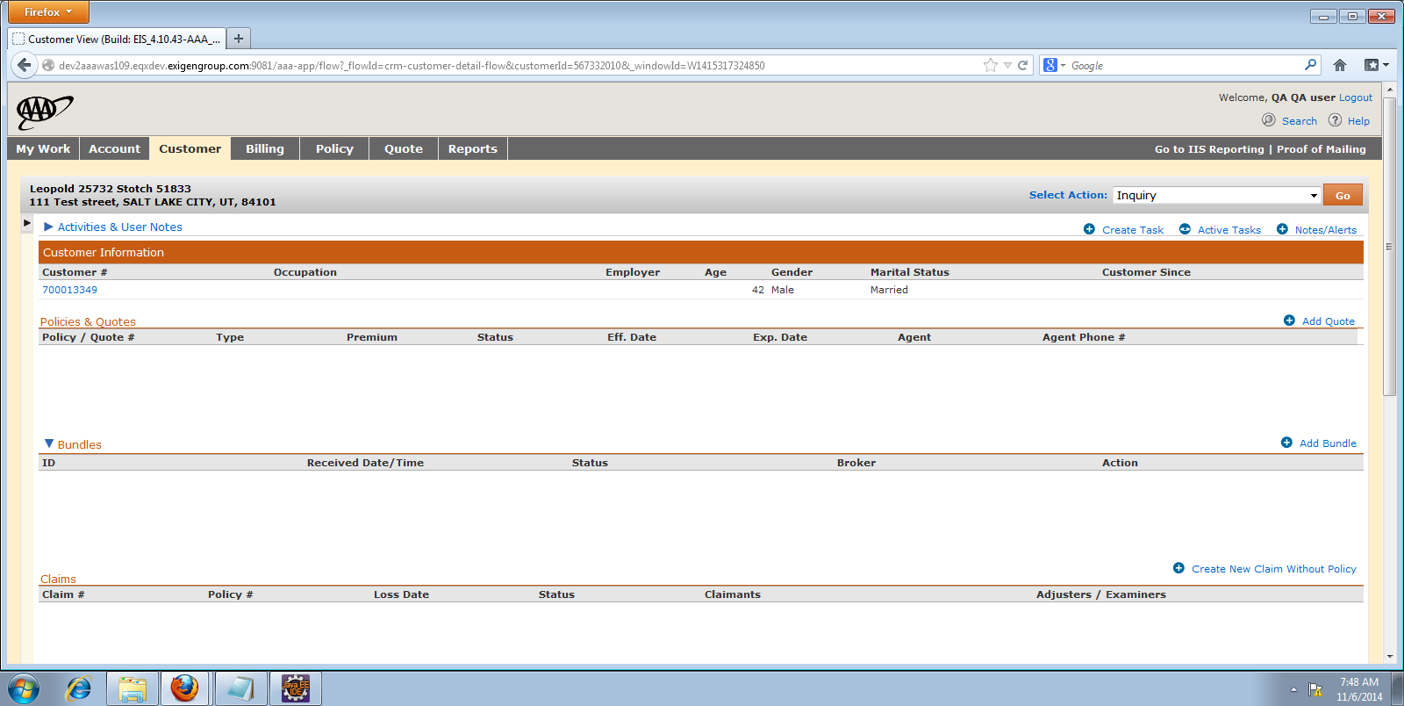

1. Select the Product:

**Applicable products for Property are:**

**Homeowners Signature Series**

**Personal Umbrella Policy**

Choose Homeowners Signature Series and click on Create New Quote

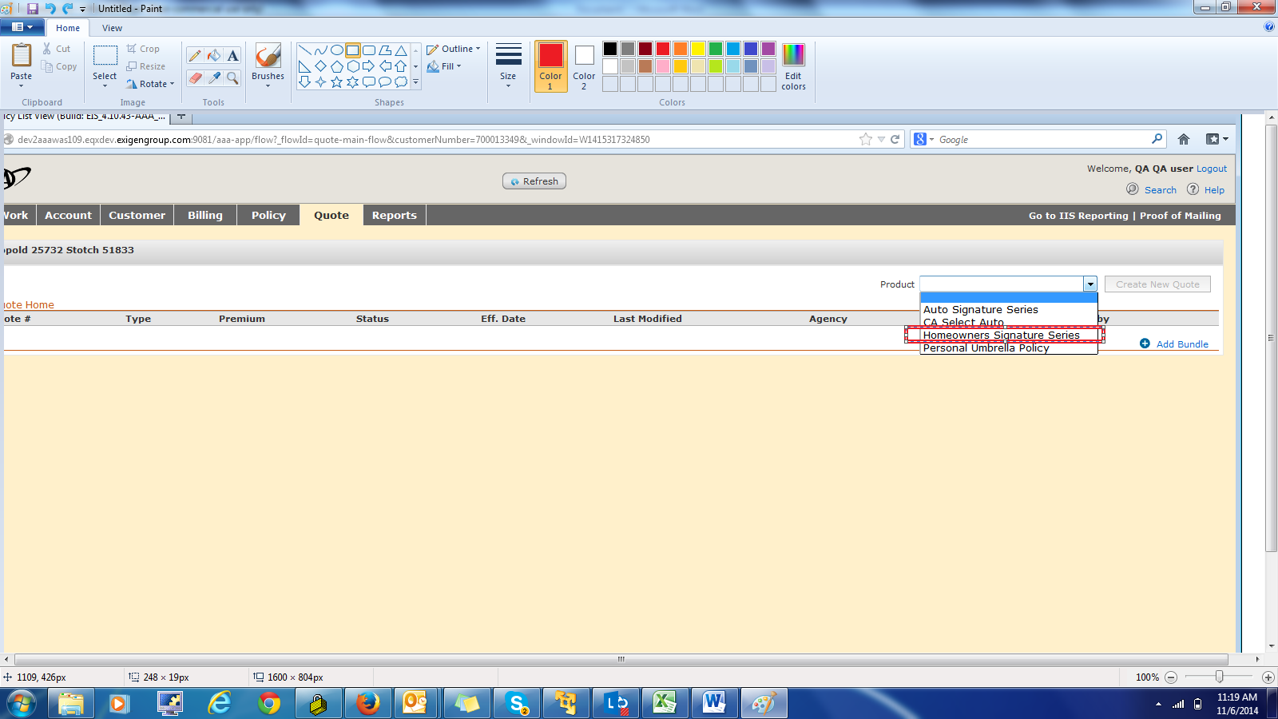

1. **General Tab:**

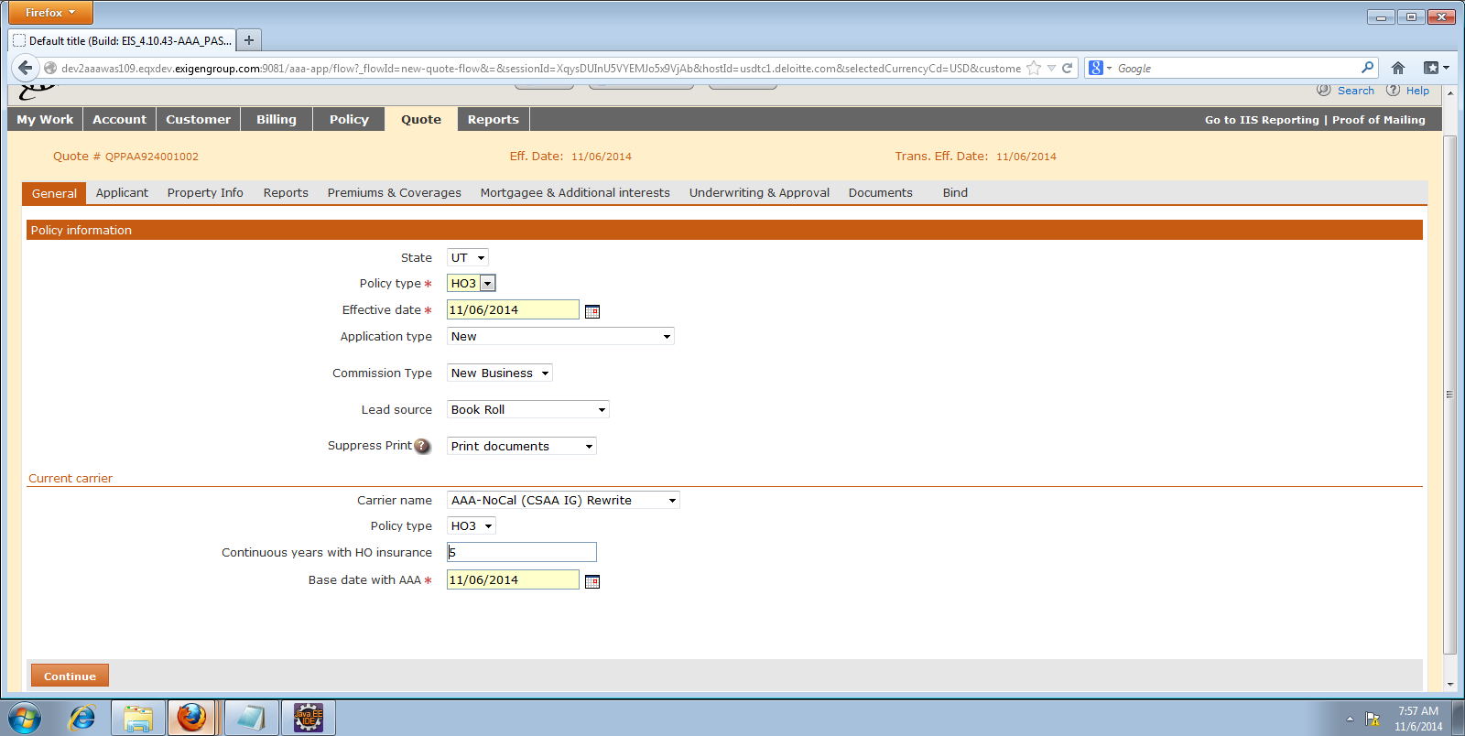

1. **Applicant Tab:**

**Click on “Add” button to add Insured.**

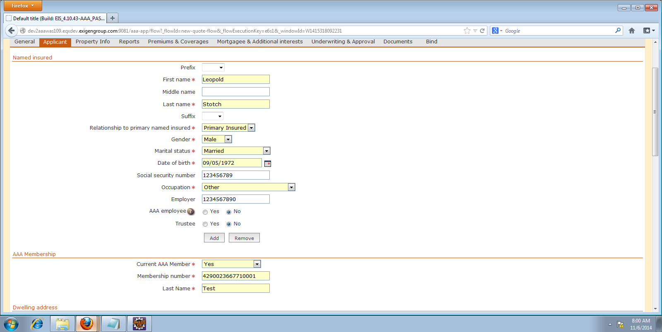

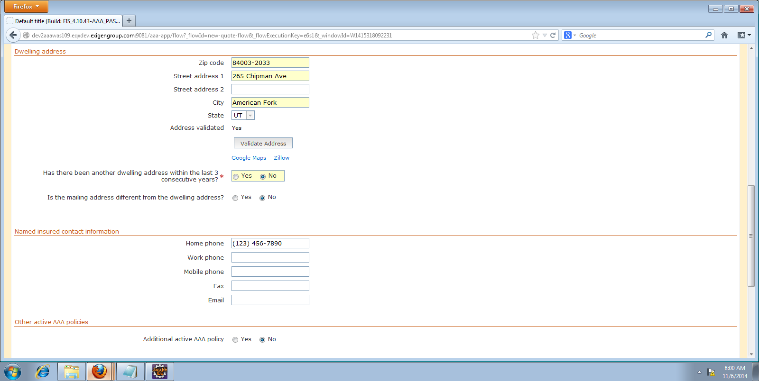

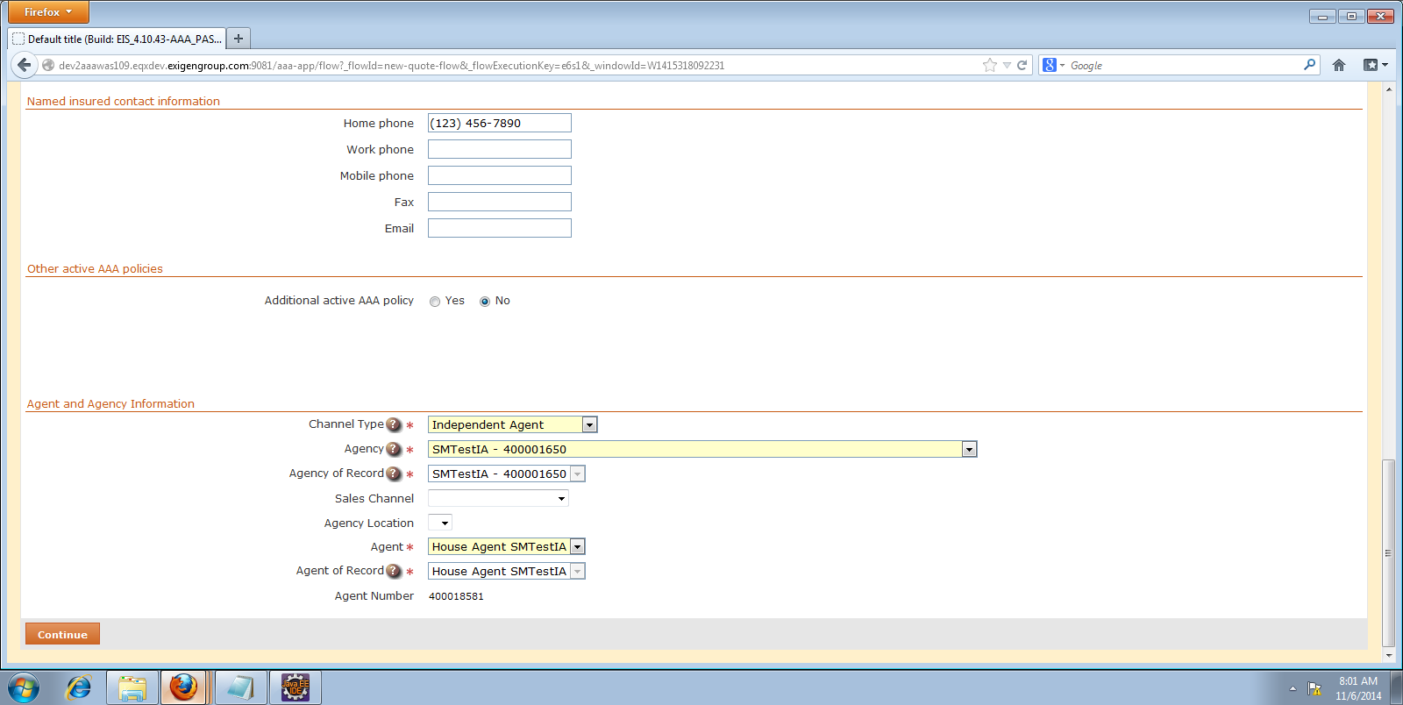

1. **Property Info tab:**

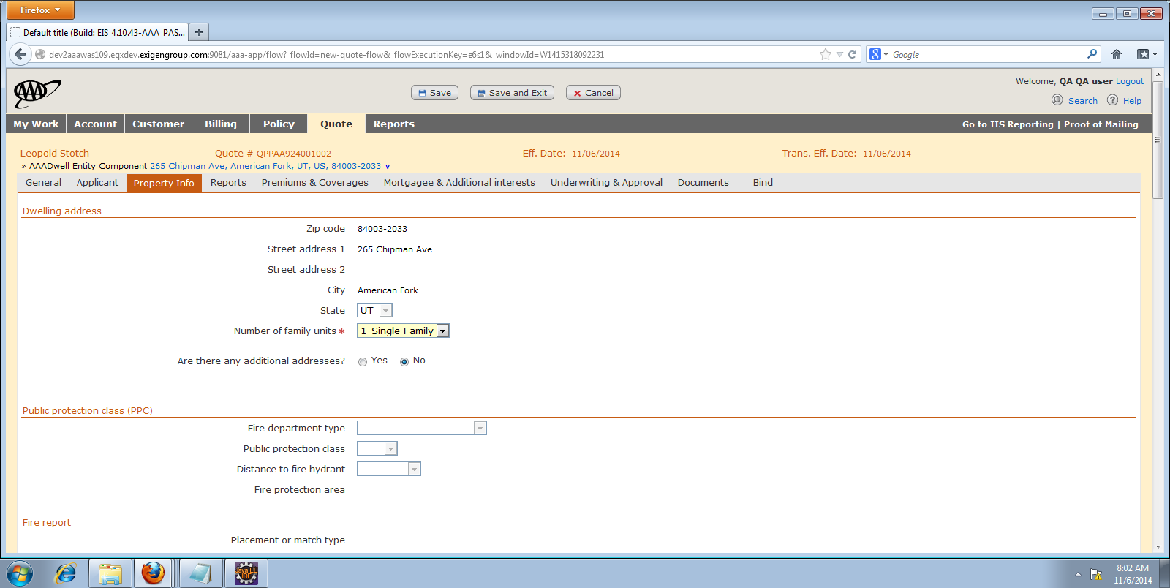

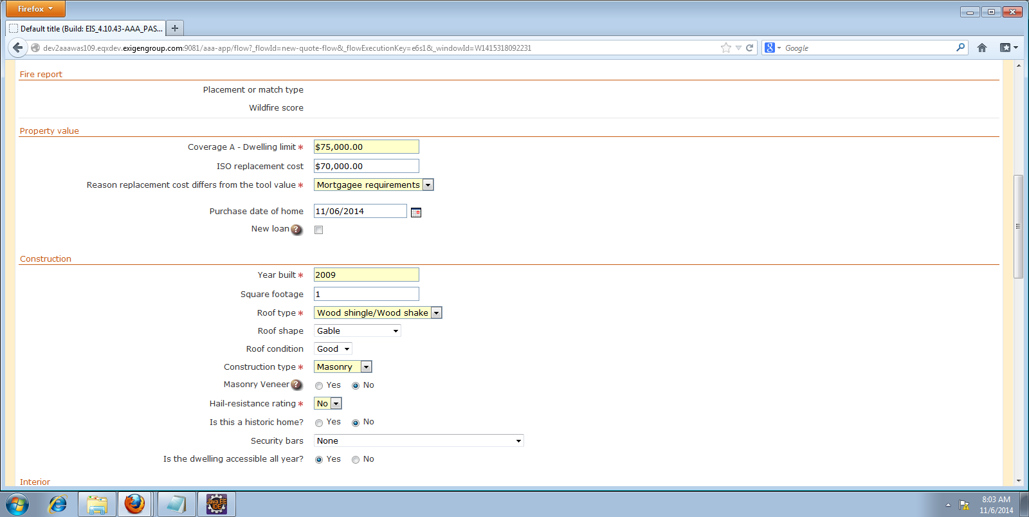

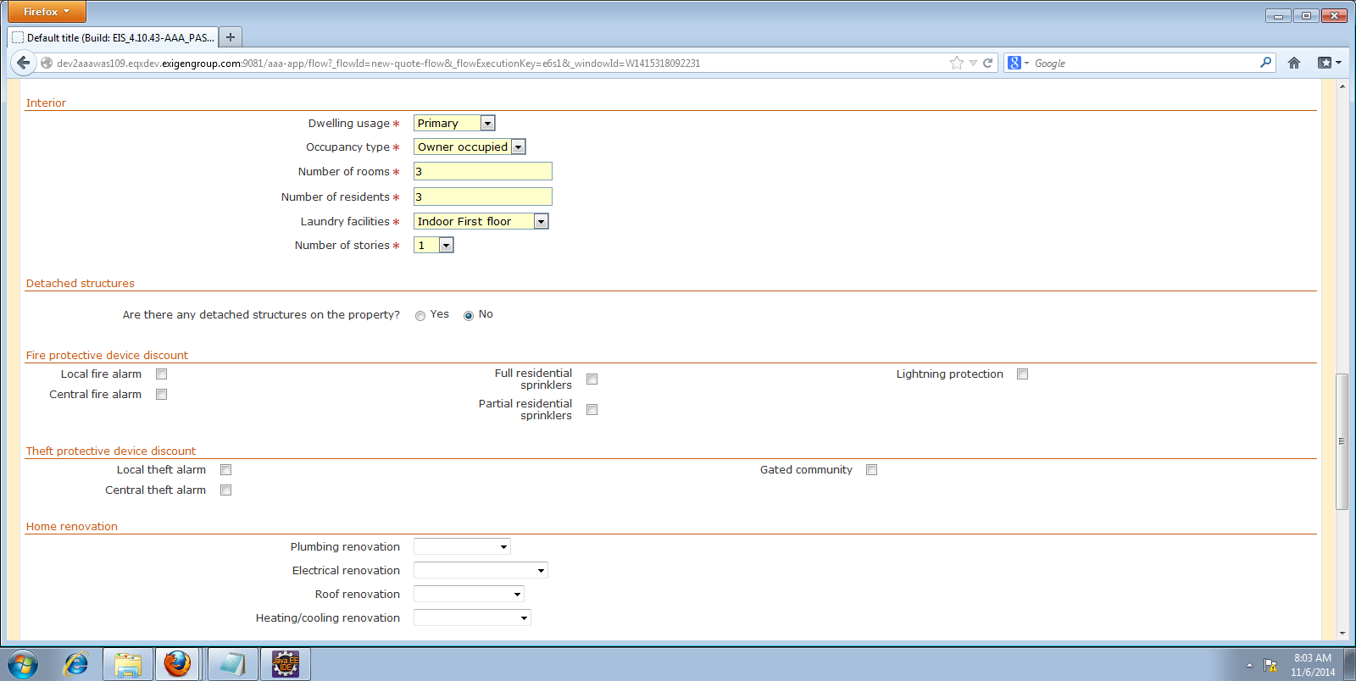

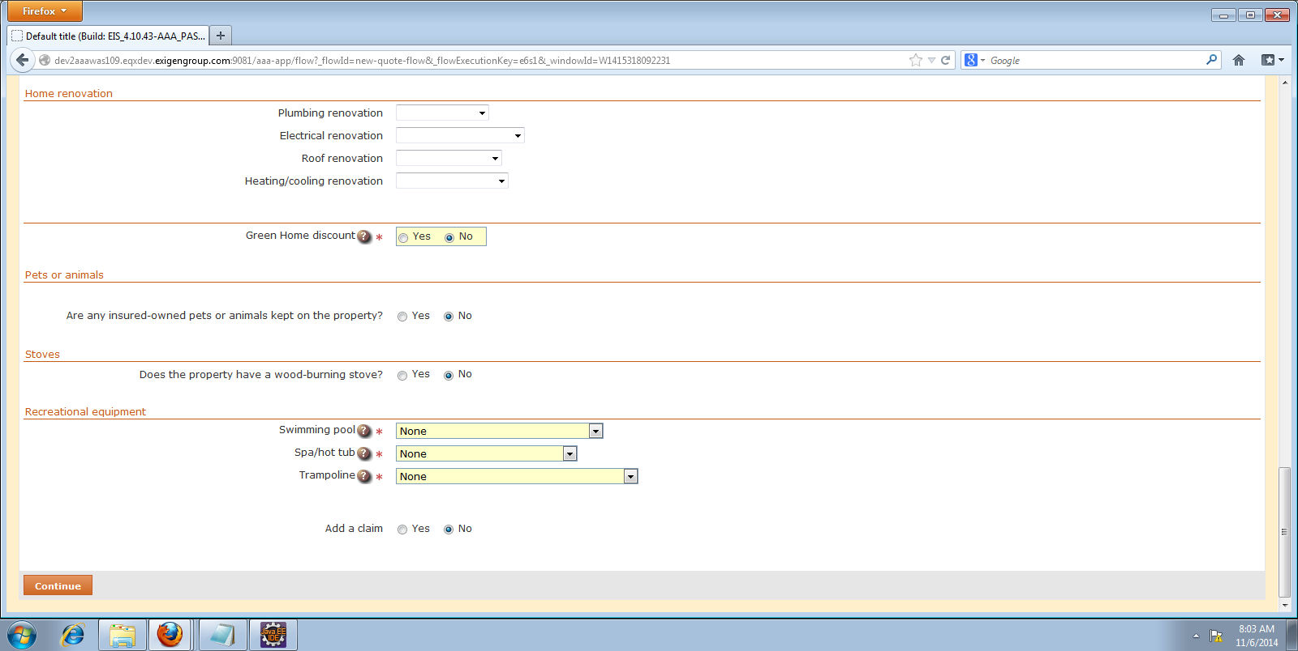

**Depending on your requirements you can add additional data for sections like Home Renovation, Recreational equipment etc.**

1. **Report Tab:**

**We need to order each Report individually.**

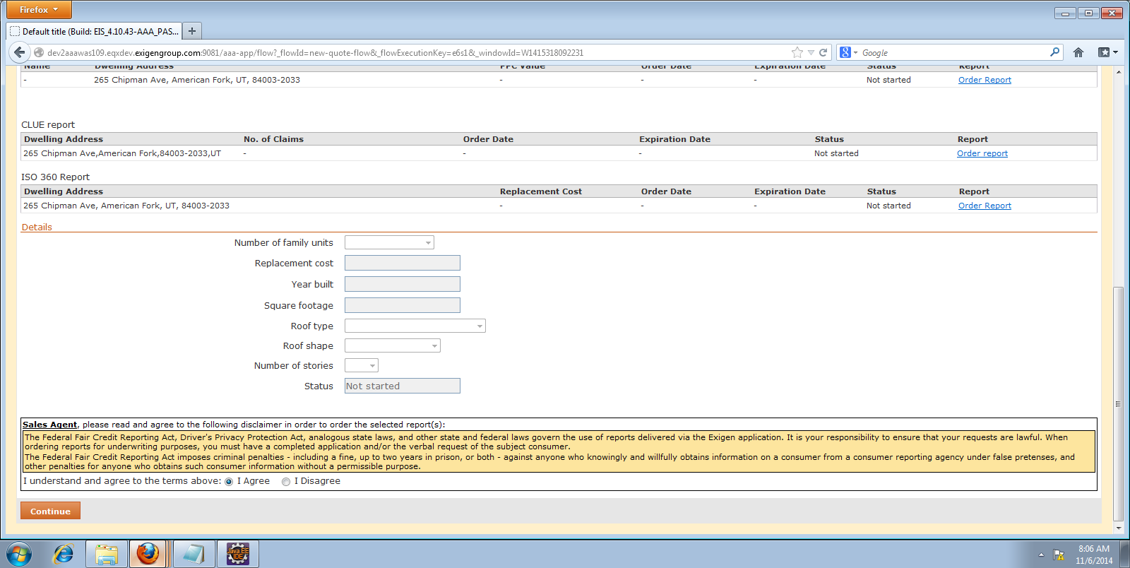

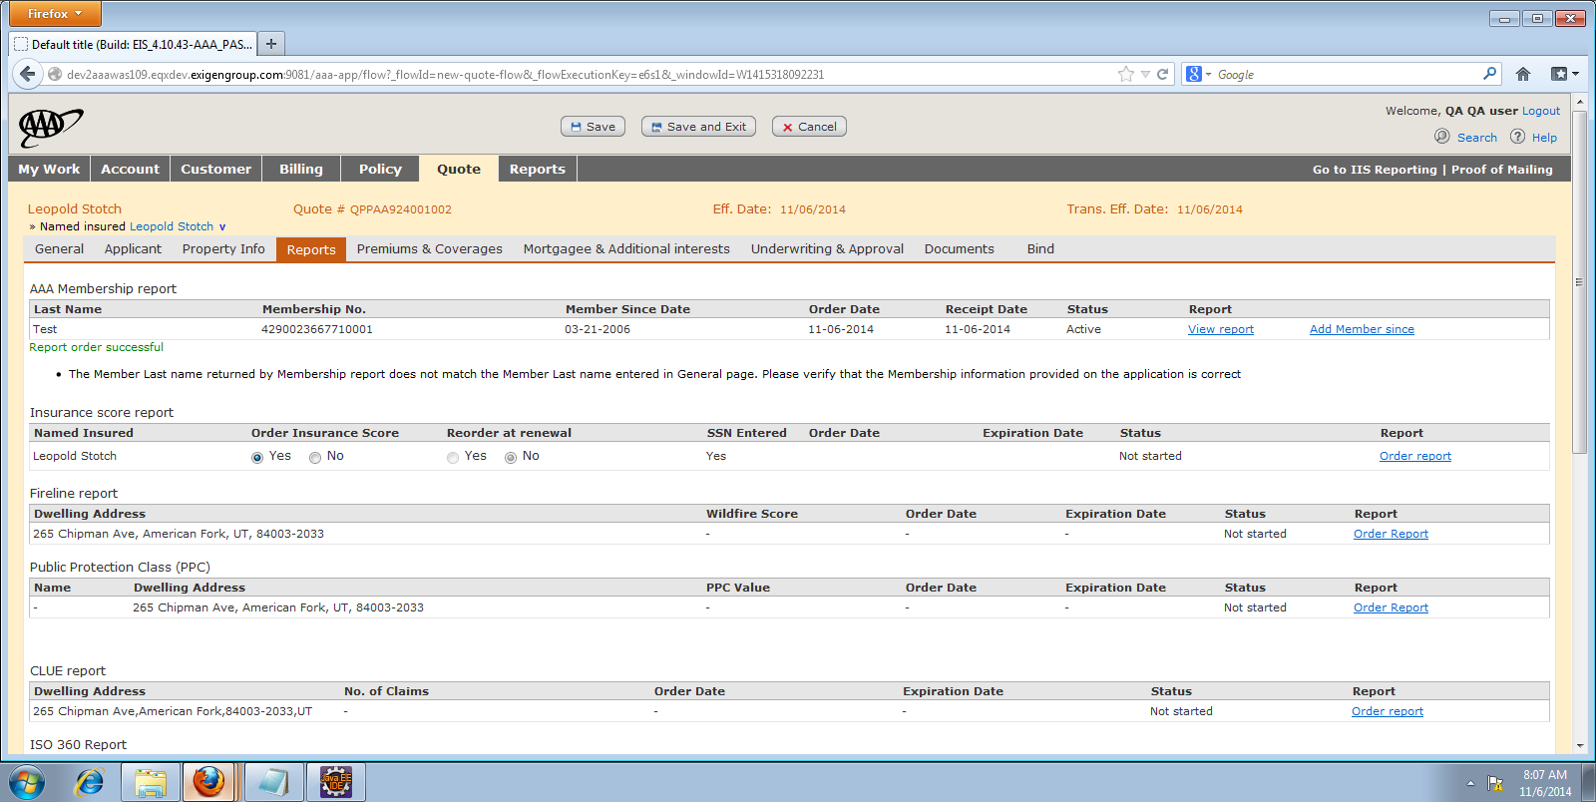

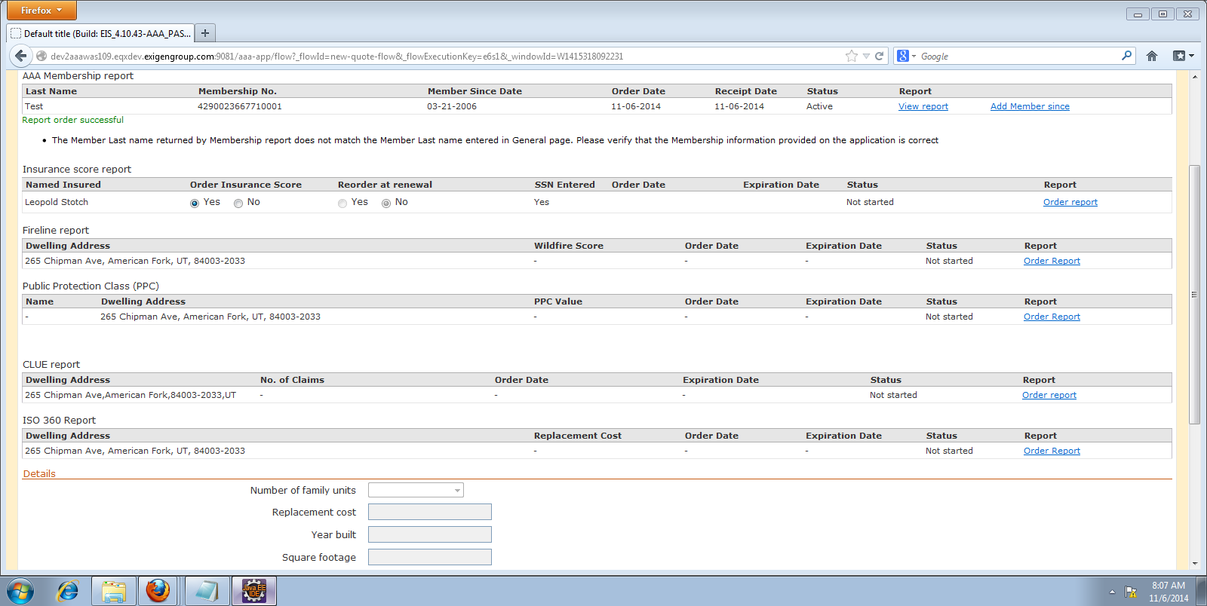

1. **Premium and Coverages Tab:**

**Product Offering:**

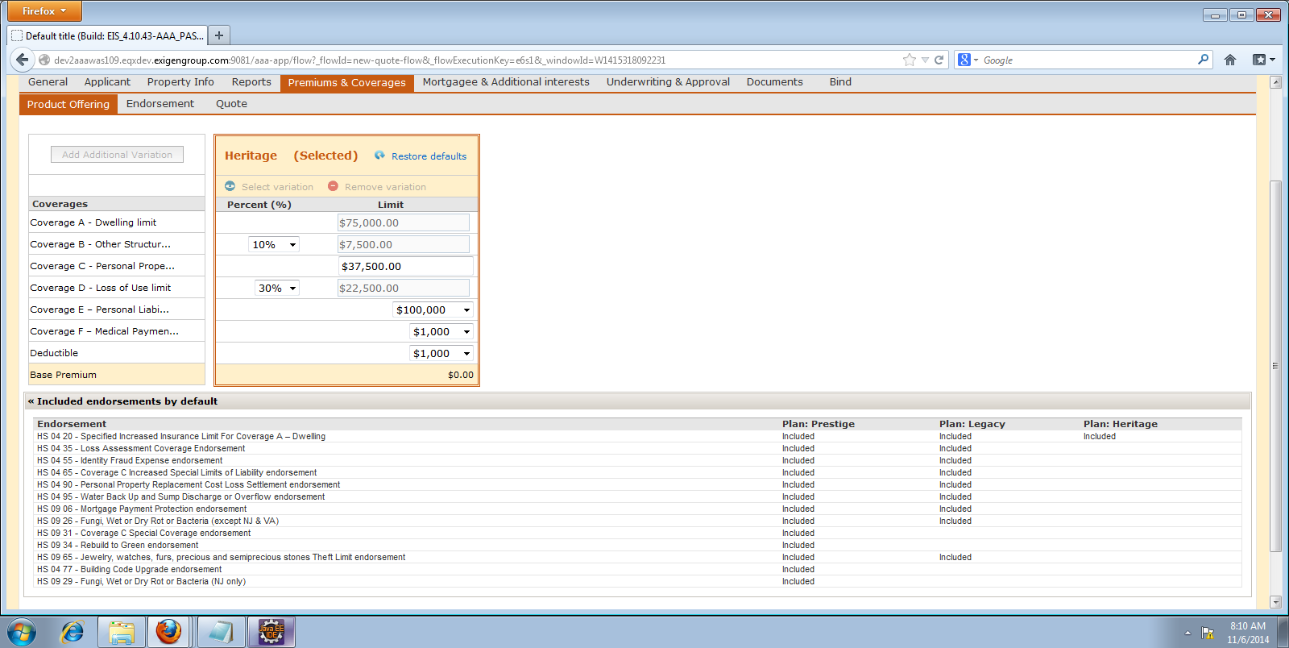

**Endorsement:**

**You can add any additional Endorsement forms in this Tab:**

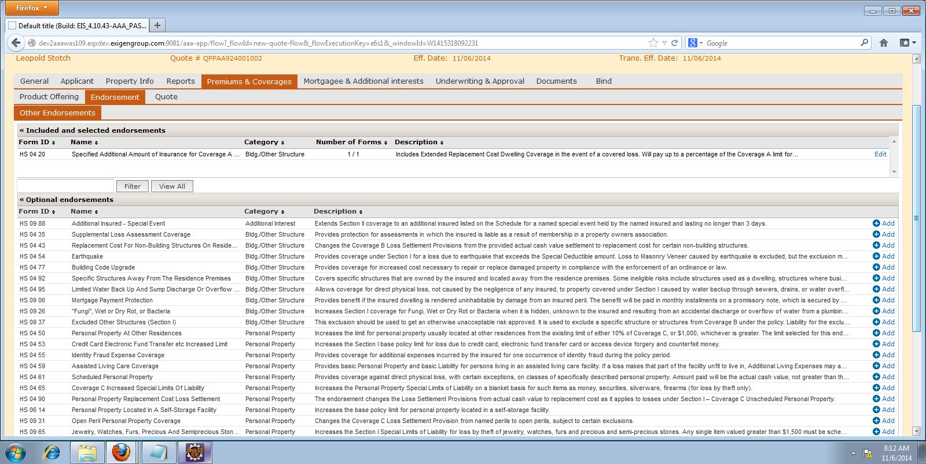

**Quote:**

**You can change the Premium Plan, Coverages and calculate premium:**

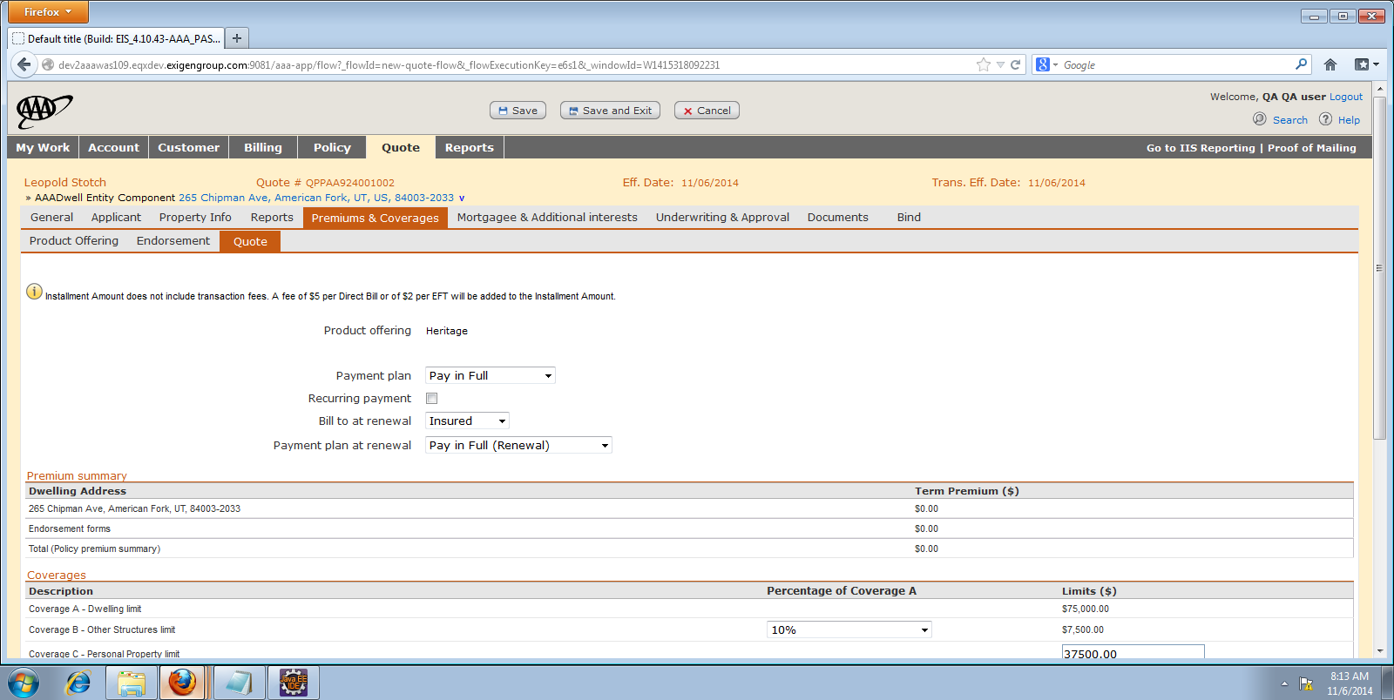

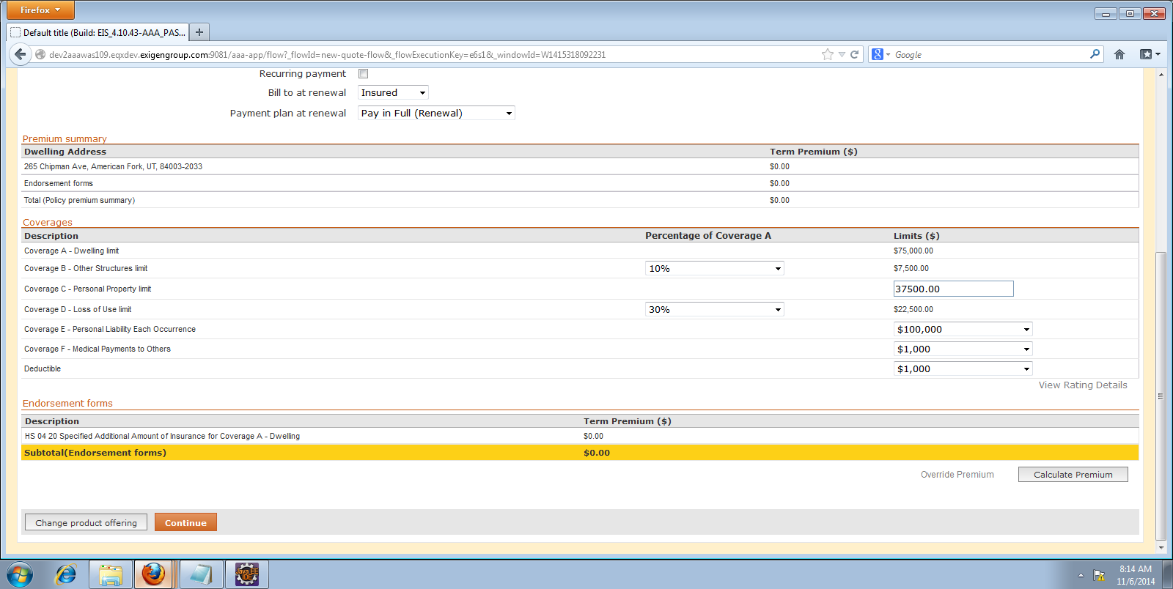

1. **Underwriting and Approval Tab:**

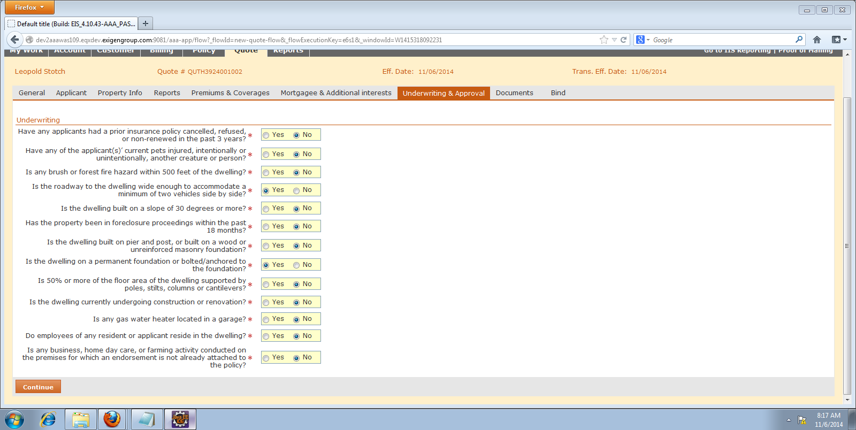

1. **Documents Tab:**

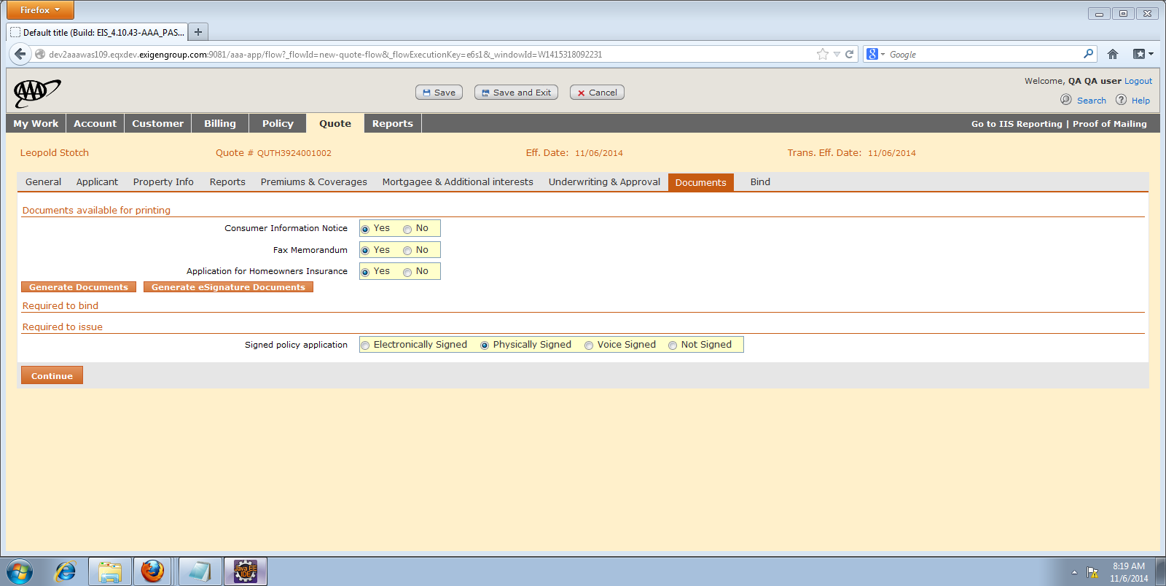

1. **Bind Tab:**

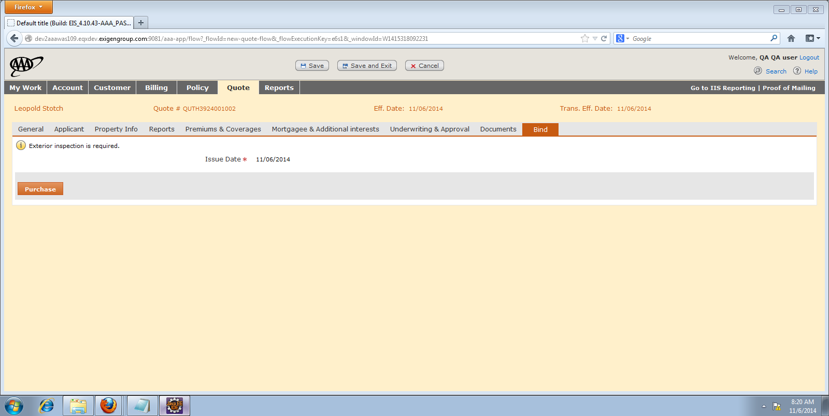

**Click on Purchase**

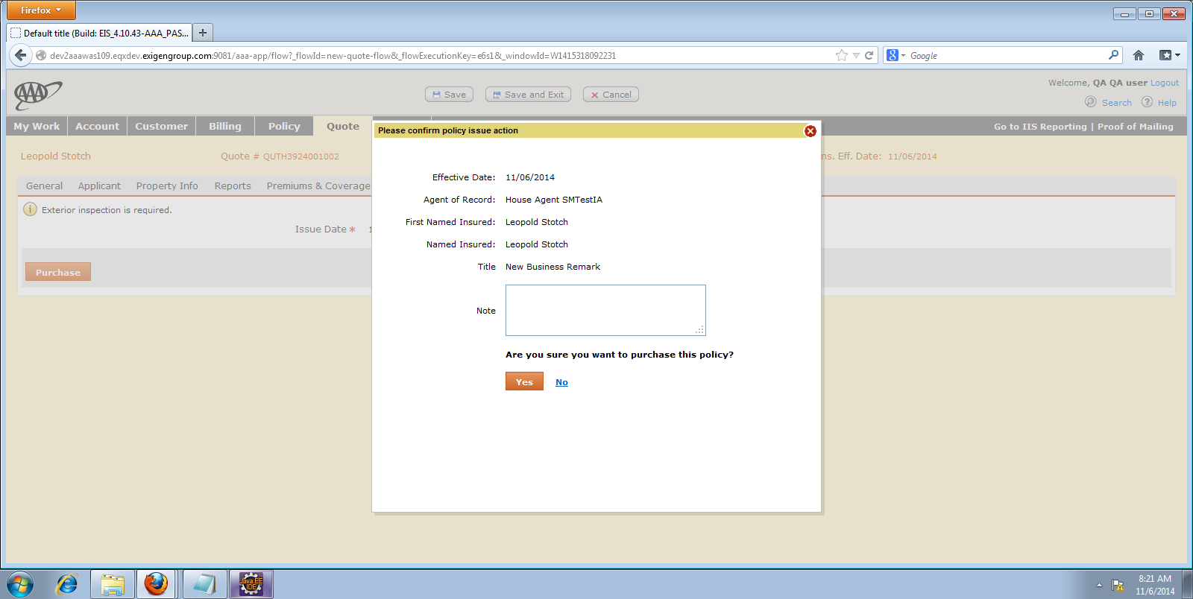

**Click on Yes**

**Payment tab:**

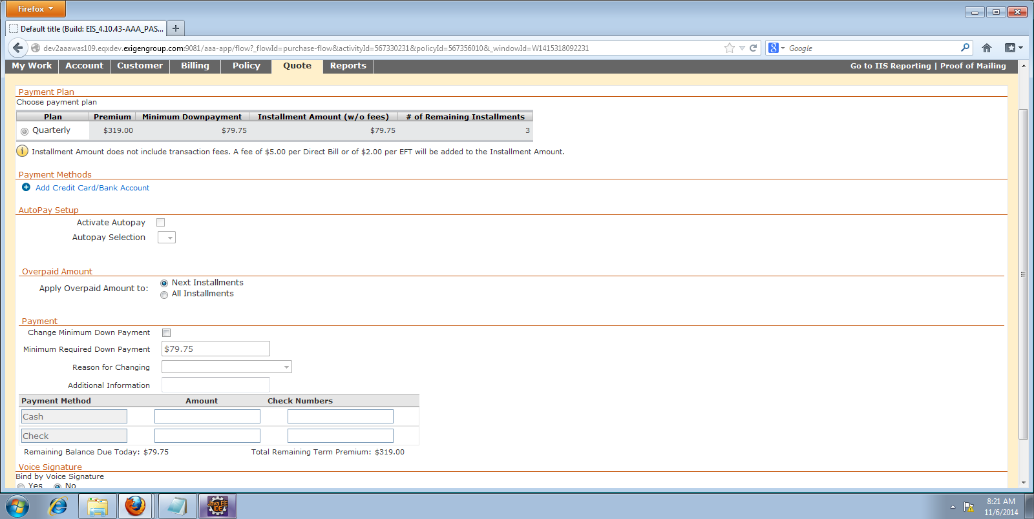

**Enter minimum amount and click on “Apply payment”**

